IMPLEMENTATION GUIDE
Continuity of Operations
Exercise Toolkit

Purpose
The Continuity of Operations (COOP) Exercise Toolkit was developed as part of ongoing efforts to increase preparedness and response capabilities for a continuity-disrupting incident that requires the activation of State Organizations’ COOP Plans. The purpose of this Toolkit is to provide customizable exercise templates for State Organizations to use to conduct a COOP exercise. The Toolkit includes the following:
- Implementation Guide – A quick-start guide for using the Toolkit and planning the exercise.
- Situation Manual (SitMan) with Three COOP Scenarios – A handout for participants to use during the exercise. Includes exercise logistics, the scenario, and high-level discussion questions.
  - Participant Feedback Form – Brief survey for participants to complete following the exercise.
- Supplemental Scenario Information – Optional, additional information that may be included in the exercise to enhance realism.
- Facilitator Manual – Instructions for the facilitator. This should not be distributed to the other exercise participants because it includes more detailed, leading questions to guide the discussion.
  - Hotwash Guide – A tool for the facilitator to use during the post-exercise participant discussion (i.e., hotwash) to guide the conversation and document participant feedback.
- Slide Deck – PowerPoint presentation that can supplement the exercise discussion.
- Sign-in Sheet – A record of participant attendance.
- Exercise Evaluation Guides (EEG) – Each module has an EEG that identifies key points of review. EEGs are only used by the evaluator(s) during the exercise.
- After Action Report (AAR) Template –Findings from the EEGs will populate the AAR and identify strengths and areas for improvement.

How to Use This Toolkit
The customizable documents included in this Toolkit provide the necessary templates for State Organizations to complete a COOP exercise tailored to fit their Organization’s needs. This Toolkit will guide exercise planners in how to use the exercise materials to plan, execute, and evaluate the COOP exercise.
Helpful Hint:
Review this Implementation Guide before planning the exercise.
While most of the exercise design elements have been completed, exercise planners in each Organization will be required to review and tailor the documents to suit the needs of their Organization. Where applicable, exercise planners are encouraged to include additional Organization details to further customize the scenario and facilitated discussion questions, and enhance realism.
Note: It is recommended that exercise planners read this Implementation Guide in its entirety first. This document provides guidance on exercise planning and tips for simplifying and streamlining the process.

Questions
If you have questions or encounter problems during the exercise planning, conduct, or evaluation process, please contact the Department of Technology and Information (DTI) Business Continuity/Disaster Recovery (BCDR) Team at DTI_COOP_Project_Team@delaware.gov.
Webinar tutorials reviewing the COOP exercise process will be made available to Organization COOP Coordinators. The Exercise Toolkit and recordings of the tutorials can be found at https://extranet.dti.state.de.us/COOP/information/calendar.shtml.

Planning Your Exercise
Although much of the exercise documentation is pre-populated, it is recommended that an exercise planning process be completed to help ensure a successful exercise. A sample timeline for completing the COOP exercise for planning purposes is shown in Exhibit 1.
Exhibit 1: Exercise Timeline

Step 1 – Establish a Planning Team and Identify Exercise Participants

Planning Team
To help coordinate exercise planning and customize the exercise materials, a small Planning Team should be assembled. Because an overall goal of this exercise is to ensure staff members understand the Organization’s COOP Plan, Planning Team members will likely include internal staff.
The Planning Team should designate an Exercise Director (recommended role for the Organization’s COOP Coordinator). The Exercise Director does not have to be the same person who facilitates the exercise discussion, although that may be helpful due to their knowledge of COOP principles, the Organization’s COOP Plan, and previous COOP exercises, and their familiarity with the exercise scenario and discussion questions.
Planning Team members should not participate in the exercise as players but should encourage their staff who would be second or third in line for essential functions/critical business processes to play. However, for smaller organizations where there may be staffing limitations, Planning Team members may participate as exercise players and/or fill multiple exercise participant roles (roles are described in the following section). Exercises present a valuable opportunity for organizations to develop “bench depth” and enhance their ability to staff critical functions over several operational periods and during the course of the emergency. Planning Team members and/or staff from external agencies can serve as evaluators.

Exercise Participant Roles
The term participant encompasses many groups of people, not just those playing in the exercise. Groups of participants involved in the exercise and their respective roles and responsibilities are as follows:
- Facilitator. The facilitator will provide situation updates and moderate discussions. They may also provide additional information and answer questions, as required.
- Players. Players are personnel who have an active role in discussing or performing their regular roles and responsibilities during the exercise. Players discuss actions in response to the simulated emergency.
- Evaluators. Evaluators observe and document certain objectives during the exercise. Their primary role is to document discussions, including how and if those discussions conform to plans, policies, and procedures.
- Observers. Observers do not directly participate in the exercise. However, they may support the development responses to the situation during the discussion by asking relevant questions or providing subject matter expertise.

Step 2 – Establish a Timeline and Schedule Meetings
As an Organization, look ahead to identify any Department-level calendar conflicts that may impact participant availability at the exercise or the ability of the Planning Team to review draft exercise materials or attend meetings. It is recommended that the Planning Team schedule and send invitations for the following exercise components listed in Table 1 as far in advance as possible:
Table 1: Exercise Components
Exercise Element | Attendees | Estimated Duration
Initial Planning Meeting | Planning Team | 1–1.5 hours
Final Planning Meeting | Planning Team | 0.5–1 hour
COOP Exercise | All Participants  (Facilitator, Players, Evaluators, Observers) | Dependent on the modules selected (See SitMan for estimated module duration.)
After Action Meeting | Planning Team and Key Leadership | 1.5–2 hours

Step 3 – Customize the Toolkit Documents
To ensure that the exercise is customized to suit your Organization’s needs, a set of two planning meetings is suggested. The overarching objectives for each meeting are listed in Table 2.
Table 2: Exercise Planning Meetings and General Objectives
Exercise Meetings | Meeting Objectives
Initial Planning Meeting | - Discuss the purpose of the exercise.  - Identify any additional Planning Team members.  - Choose the exercise scenario.  - Confirm the exercise objectives, applicable modules based on Organization’s capabilities, and discussion questions.  - Identify an exercise facilitator.  - Determine exercise logistics (location, participant list, evaluators, invitations, etc.).  - If not already done so, register your exercise.
Final Planning Meeting | - Review the drafted exercise materials and identify any corrections or modifications.  - Finalize all exercise materials.  - Confirm exercise logistics.

Customization Guidance
A primary task of the Initial Planning Meeting is to identify the necessary customizations within the exercise documents. It is recommended that the Planning Team begin reviewing and customizing the SitMan first. The SitMan content will guide the Planning Team through the majority of scenario, module, and discussion question decisions. Once these decisions are made and finalized, migrate the content into the Facilitator Guide, EEGs, and Exercise Slide Deck. The following sections provide an overview of content that requires customization.
Helpful Hint:
Begin reviewing and customizing the SitMan first.

Highlighted Fields
[Highlighted fields] throughout the document indicate where information should be customized (e.g., information specific to the Organization, or requiring a decision). Delete any text or fields that do not apply. To remove the highlighted text, select the text and click the “Text Highlight Color” function in the toolbar, and click “No Color” to remove the yellow highlight. For guidance, please see Exhibit 2.

Exhibit 2: Removing Highlighted Text
1. Select the text
2. Navigate to the “Text Highlight Color” function
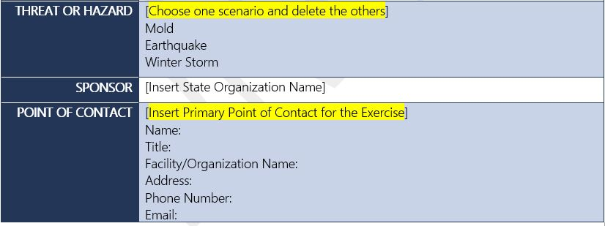

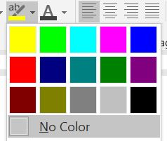

3. Click “No Color”

Autofill Document Property Fields
Important Timesaving Tip: “Autofill Document Properties” fields are used throughout the documents to streamline customization. Within each document, fields including [Insert State Organization Name] and [Insert Date of Exercise] are linked, and will automatically update once any instance is populated. However, the field must be entered the correct way, or the link will be broken and the remaining fields will not be filled. Exhibits 3 and 4 show examples of the Autofill Fields and how to correctly enter them, respectively.
Exhibit 3: Autofill Document Property Field Examples
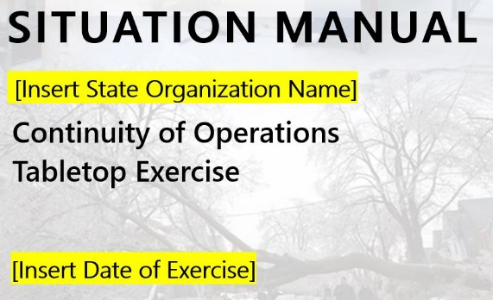
Populate these fields first.
They will automatically fill contents in the remainder of the document.

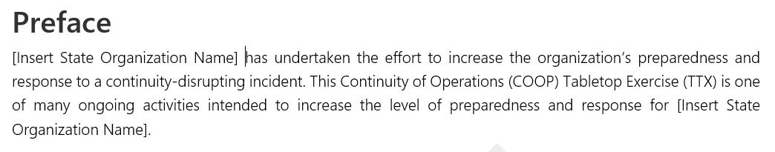

Use the following steps to correctly change the information within an Autofill Field without breaking the link:
- Hover over the text. You should see a light grey box appear.
- Click once on the field.
- Highlight all the text within the field and then type in your Organization’s information. You should still see a light grey box with “Publish Date” or “Company”. Do not double click to select the whole field or the link will be broken.
- Click out of the box and the remaining fields will automatically populate.
Exhibit 4: Autofill Document Property Field Examples
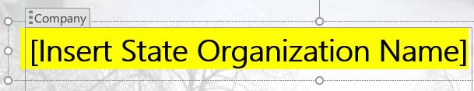
Click once in the field.

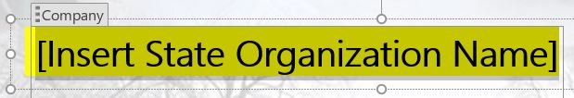
Highlight the text within the field.

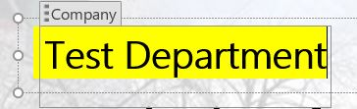
Enter information and click out of the box.

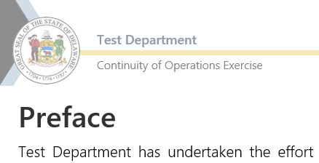
Confirm the fields have automatically populated.

If the field does not automatically populate, the link may have been broken. Click undo and repeat the steps above to re-try.

Scenario
Three plausible continuity-disrupting incidents have been developed for this Toolkit:
Scenario #1: Mold
Scenario #2: Earthquake
Scenario #3: Winter Storm
Scenario information for all three hazards is already incorporated into the exercise documents. Organizations can select any scenario they wish. Once the Planning Team finalizes the scenario, the other two scenarios should be deleted. The module questions are applicable to all scenarios.
Suggestions for peripheral scenario information can be incorporated from the Supplemental Scenario Information document. While participants should be encouraged not to fight the scenario, additional information can be incorporated to enhance realism.

Modules
The exercise was designed with four modules. These modules follow the COOP Plan outline and guide participants through a scenario progression of Initial Notification and Activation, to COOP Operations, and lastly to Reconstitution. While the modules do not have to be completed in one sitting, it is recommended that they be completed in order.
Module 2A was included as an optional module to challenge Organizations with more advanced COOP Plan capabilities. Module 2A includes a selection of scenario injects that planners can choose to include or customize for their Organization. Organizations may work through as many scenario injects as they wish. If Organizations choose not to complete Module 2A, they should delete that section from the exercise documents.

Discussion Questions and Exercise Evaluation Guides
Discussion questions have been designed for each module. The Planning Team should review and tailor the key discussion questions as appropriate for their Organization. As you review the exercise documents, you will see that the questions in the SitMan, Facilitator Guide, EEGs, and AAR are numbered similarly (e.g., Module 1, Question 1 in the SitMan is similar to Module 1, Question 1 in the Facilitator Guide). This is intentional and serves multiple purposes, including:
- Ability to quickly reference questions by number during exercise discussions
- Straightforward completion of the EEGs by evaluators
- Streamlined AAR population
The questions are worded slightly differently between the documents to provide the audience with the information they require. Facilitators are provided with more information and COOP Plan section references to prompt follow-on conversation and direct participants where to find the information if they are struggling.
Note: If discussion questions are deleted or modified by the Planning Team, it is advised that a similar action happens across all documents (e.g., if Module 1, Question 4 is deleted from the SitMan; it should also be removed from the Facilitator Guide, EEG, and AAR template).

Step 4 – Complete the Exercise Planning Process
After the exercise documents have been customized, allow the Planning Team time to review the final documents. The Final Planning Meeting can be used to discuss any final revisions and confirm exercise logistics.

Step 5 – Conduct the Exercise
Helpful Hint:
Planning Team members are often great exercise evaluators and can be additional sources of observations for developing the AAR.
Using the customized Toolkit documents and slide deck, the facilitator will conduct the exercise. The recommended distribution of exercise documents and recipients is identified in Table 3. It is recommended that the facilitator and evaluators receive their documents well in advance of the exercise. This will allow them time to become familiar with the questions and evaluation criteria. Player documents should be distributed at the beginning of the exercise.
At the conclusion of the exercise, the facilitator will direct participants to complete the Participant Feedback Form within the SitMan. Once the forms are completed, the facilitator will use the Hotwash Guide (within the Facilitator Guide) to conduct a brief discussion with the participants to obtain initial feedback on the discussion points of the exercise as well as suggestions for improvement actions. The facilitator will collect Participant Feedback Forms before dismissing participants. Exercise evaluators will complete and turn-in their EEGs for incorporation into the AAR.
Table 3: Suggested Distribution of Exercise Documents
Exercise Participant | Exercise Document
Facilitator | - Facilitator Guide  - Slide Deck  - Sign-In Sheet
Evaluators | - SitMan  - EEGs
Players | - SitMan  - Copy of COOP Plan
Observers | - No additional documentation is required. SitMan is optional.

Step 6 – Complete the After Action Process
Populate the AAR using findings from the EEGs, notes from the hotwash, and participant feedback. In doing so, identify improvement recommendations and actions that can improve existing facility plans and protocols. Example recommendations include:
- Update an existing plan to incorporate missing elements, including the process of reconstitution.
- Identify an alternate facility.
- Formalize a Memorandum of Understanding for the alternate facility.
- Pre-identify resource needs and identify where to request resources.
- Test crisis communications.
Review the draft AAR with the Planning Team and key leadership during an After Action Meeting (AAM). During the AAM, establish which improvement actions will be memorialized in the Improvement Plan (IP) (see Step 7 for additional information). Populate the IP with the recommendations. Additional actions on the IP will be completed in Step 7. Once the AAR is finalized and has been endorsed by leadership, distribute the AAR to DTI BCDR via DTI_COOP_Project_Team@delaware.gov. High-level findings of COOP exercises will be synthesized into a final State of the State COOP Report.

Step 7 – Complete the Improvement Plan
During the AAM, the IP will be populated with recommendations that the Organization would like to see implemented. Leadership and personnel should populate the remainder of the IP with the corrective action, primary organization (if different from the organization conducting the exercise), identify a point of contact, and assign start and completion dates. The IP is an internal Organization document and serves as a roadmap for improving COOP capabilities.

Tips for Success
- Schedule and plan the exercise in advance.
- Allow enough lead-time on the exercise date to maximize participation of invitees.
- Review all exercise document templates and materials before scheduling the first planning meeting.

